Game Design document

By David Jeffrey B00257681 and Merissa Coulter B00329732

Contents

Game Overview 2

Setting/Environment 2

Level design/Layout 3

Font 4

Colour Palette 4

Concept Art/Storyboard 5

Inspiration 7

Target Audience 8

Background 8

Characters 9

NPCS/AI 9

Music and Sound Effects 9

Game Mechanics 9

Controls 10

Test Log 10

Software Methodologies 10

Bibliography 10

Technical Document 11

Functional and Non-Functional Requirements 11

# Game Overview

# 

When the game begins, a menu screen will appear with options for the player to select new game or exit. Selecting new game will start the player in the locked room which the player will need to find a key to open the door.

The game will be set as a first-person shooter with the character being able to pick up a weapon to fight the enemies. The player will have a limited amount of health which will decrease when the enemy attacks and can also increase when the player receives a health potion. The player will also receive unlimited ammo, making it a bit easier for the player. The health potions will be dropped when the enemy is killed by the player. The AI will be controlling the enemy which they will attack when the player enters the room and it will be able to follow you to a certain extent when in contact. One or two of the enemies will be able to follow you out of the room until a certain distance of which they will either remain still or return back to the room they came from. These enemies will also have a certain amount of health and will disappear from the game when killed.

At the end, the player will end up in a larger room when multiple enemies will spawn and attempt to kill the player. If the player dies, the player will have the option of restarting the game or exiting. As well as the multiple enemies at the last room, there will also be a “boss” enemy which will have more health and an increase to its attack damage. If the player manages to kill the boss, then the player will open the last door to which the game will end, ending the game on a cliffhanger.

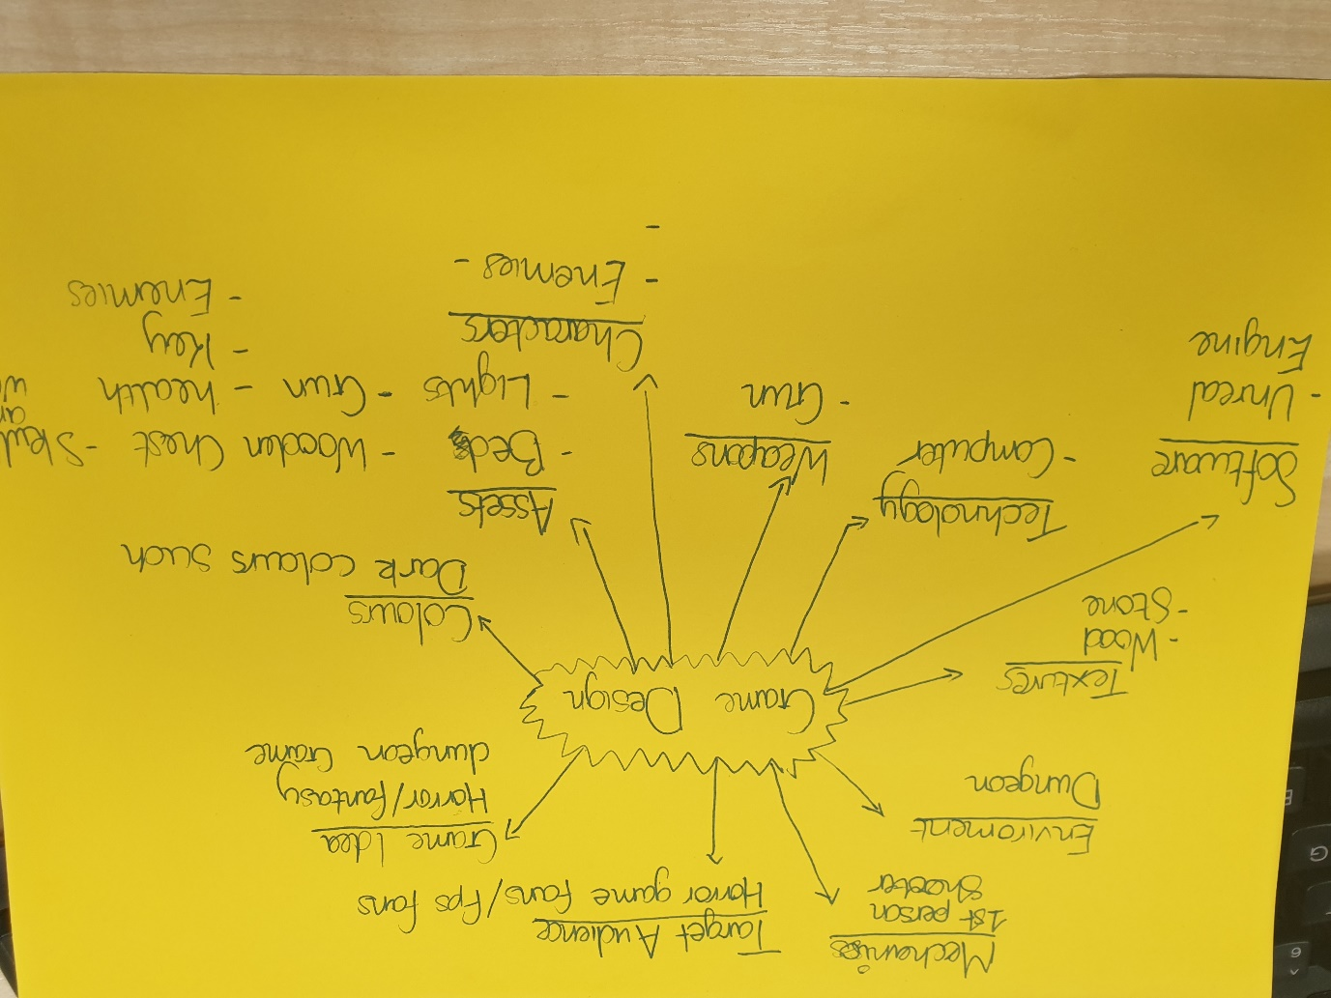

## Setting/Environment

The prototype of the game will be set in the horror genre more specifically in a dungeon environment where the player finds themselves in a locked room . The aim of this game is for the end user to explore the dungeon killing enemies they are trying to attack you.

# Level design/Layout

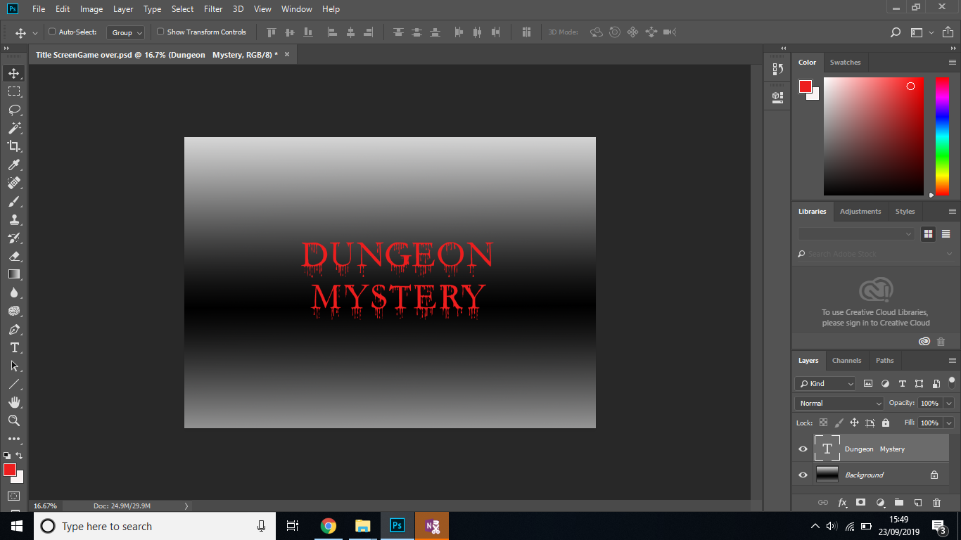

Created the background for the title screen and game over screen on Photoshop by using the gradient map and gradient tool to get the effect that I wanted I then downloaded a font to add to the title for the horror/fantasy effect on the text

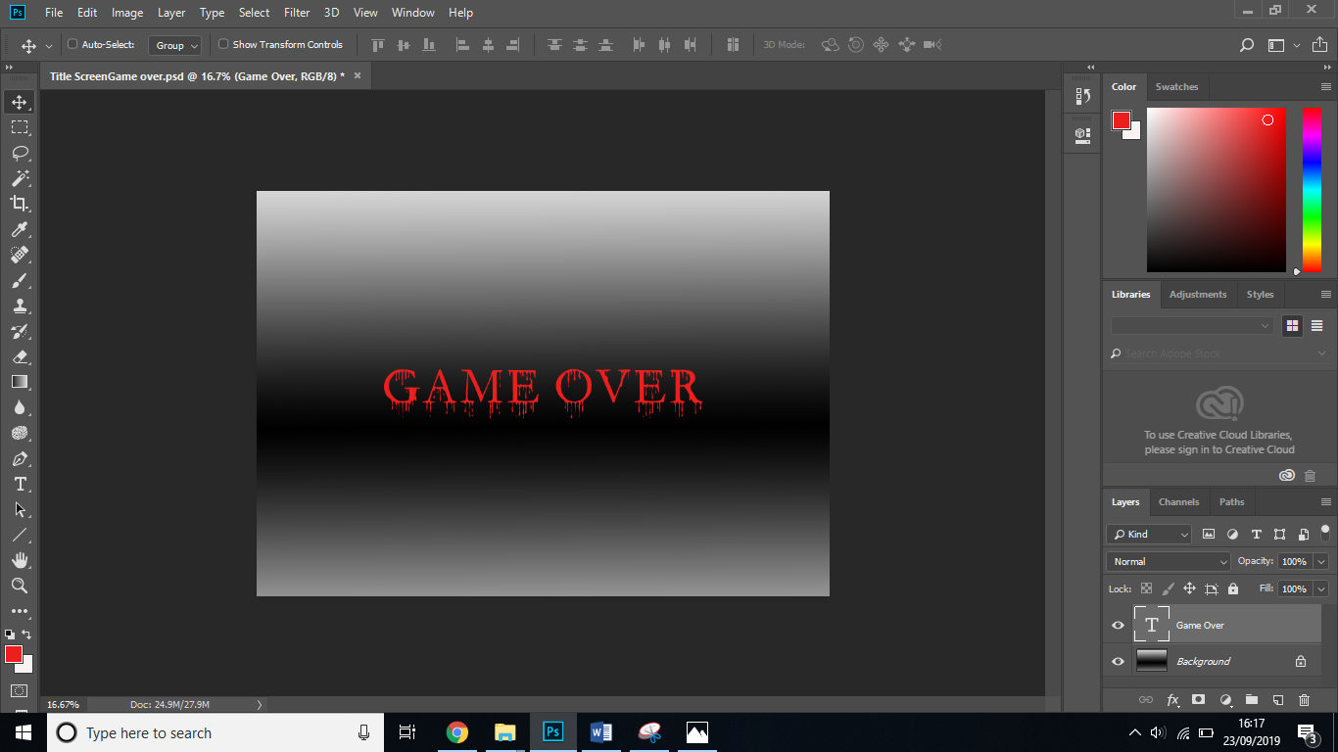

# Font

[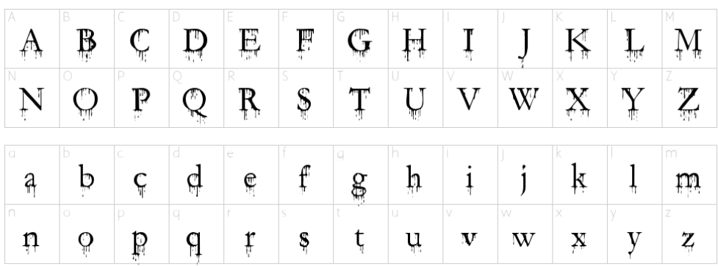](https://www.1001freefonts.com/horror-fonts-2.php)

# Colour Palette

|  |  |  |
| --- | --- | --- |
| Image | Colour | Colour Code |
|  | Yellow | #C2AD2B |
|  | Grey Blue | #517186 |
|  | Gold | #A99232 |
|  | Black | #302F2D |
|  | Blue | #5373A3 |
|  | Dark Brown | #87645C |
|  | Red | #AA3922 |
|  | Light Brown | #CDB1A0 |
|  |  |  |

# Concept Art/Storyboard

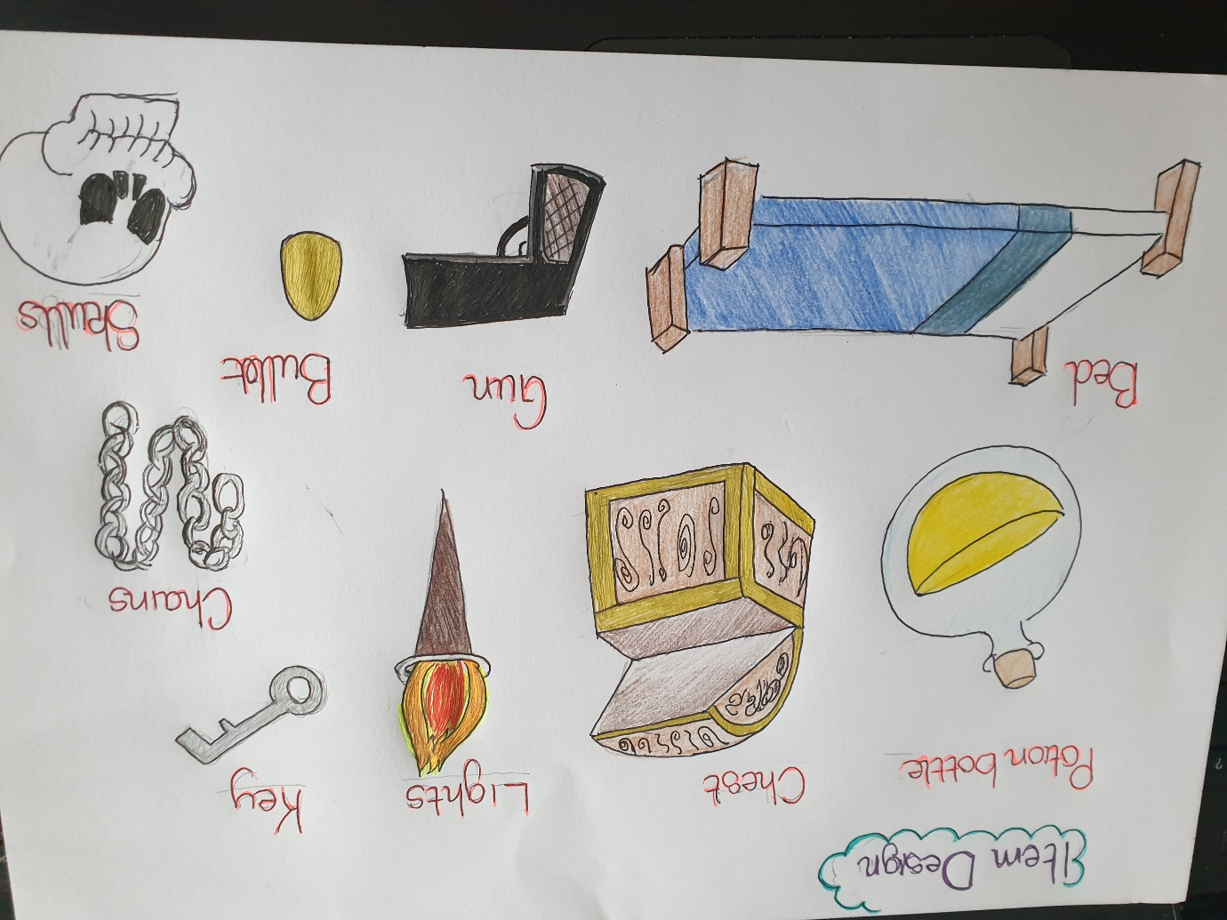

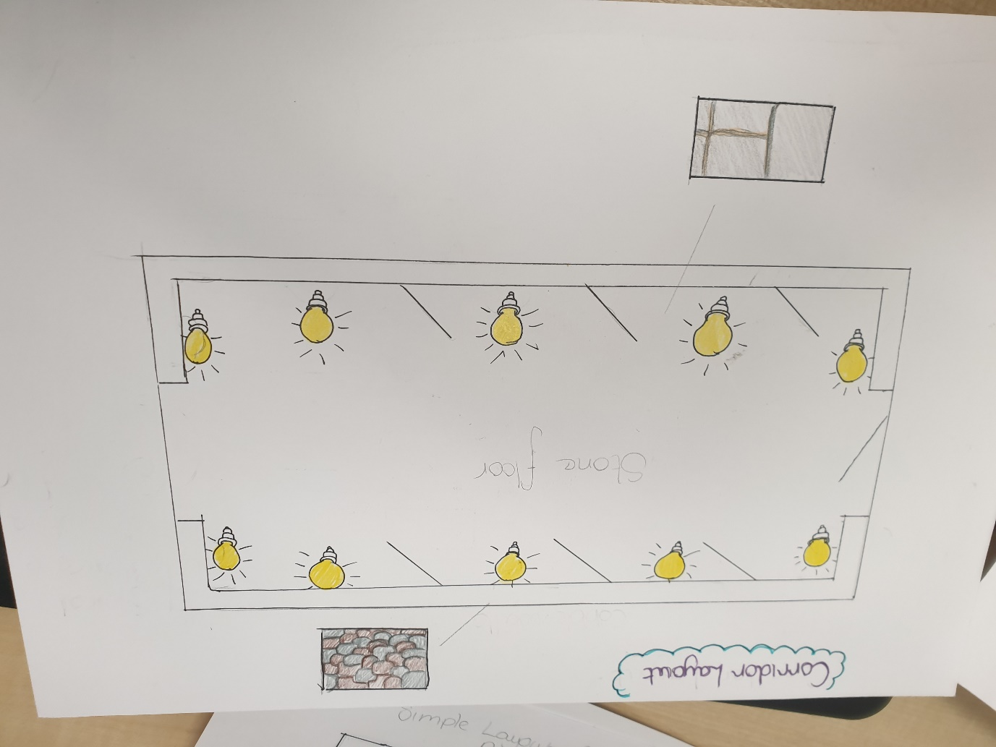

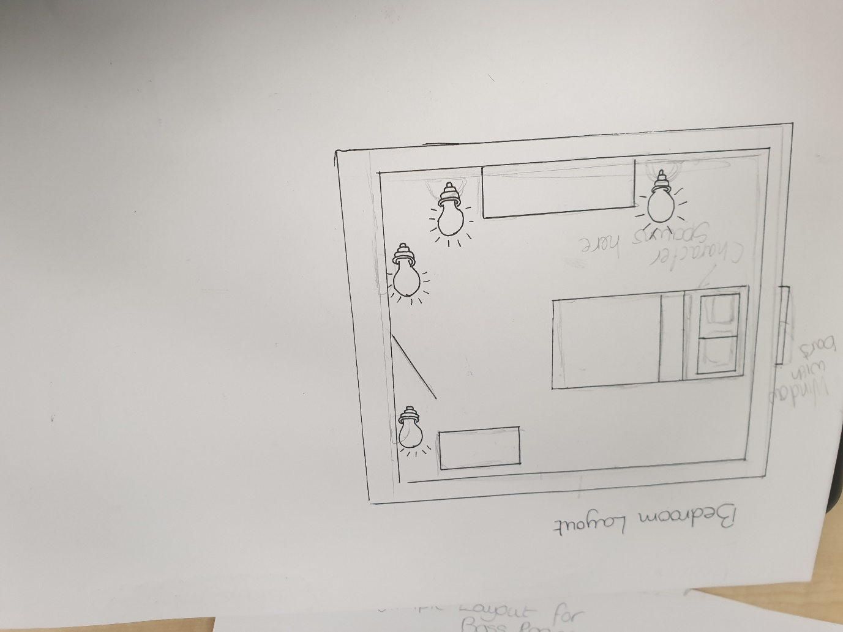

## Inspiration

We decided to create the game in this style as we are players that enjoy the horror experience from games such as DOOM, Until Dawn and Resident Evil and we wanted to give the players a sense of mystery and darkness.

Doom 1990’s

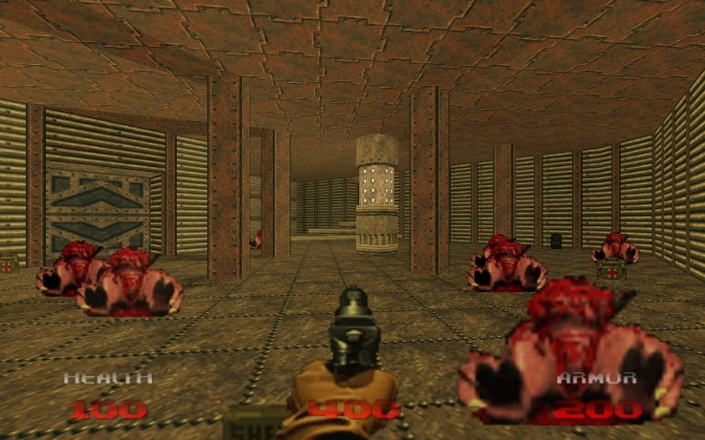

Until Dawn 2015

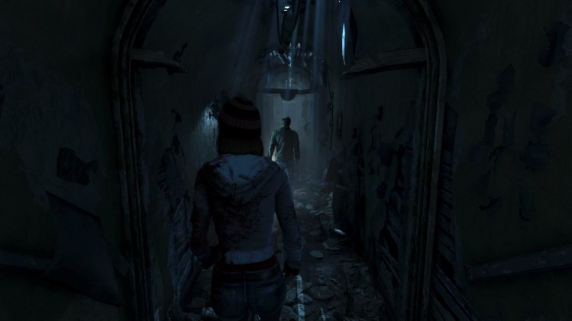

Resident Evil 2 1998

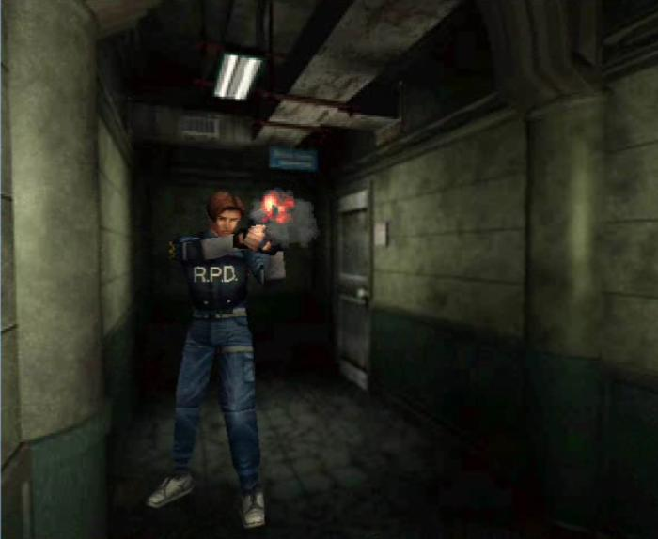

## Target Audience

## Background

## Characters

The enemies that we have decided to include in the game are zombies. The models animations for the zombie will be taken from www.mixamo.com , which is a website that contains 3d models and animations for different characters. The zombie will have a limited amount of health and their attack will be a standard melee attack which will hurt the character. They will also have limited vision and range.

## NPCS/AI

# Music and Sound Effects

# Game Mechanics

# Controls

# Test Log

# End User Feedback

# Software Methodologies

# Bibliography

Resident Evil Image

<https://www.bing.com/images/search?view=detailV2&id=8B0BC186FB2B086F791A64A0C6474B4109F082FF&thid=OIP.3mD7x9LE-2UB9wyQK1ZJoQHaGE&mediaurl=http%3A%2F%2Fs.emuparadise.org%2Ffup%2Fup%2F52707-Resident_Evil_2_(E)_(Disc_1)_(Leon_Disc)-1.jpg&exph=574&expw=700&q=Resident+Evil+2+PS1&selectedindex=3&ajaxhist=0&vt=0&eim=1,2,6>

Until Dawn Image

<https://www.bing.com/images/search?view=detailV2&id=1363A8AB63ECB1E07519F45FC5465D5FD61850B4&thid=OIP.E84xbWoB4donzjsCLSycAQHaEK&mediaurl=https%3A%2F%2Fi0.wp.com%2Fdarkzero.co.uk%2Fasset%2F2015%2F08%2Funtil-dawn-4.jpg&exph=1080&expw=1920&q=until+dawn&selectedindex=156&ajaxhist=0&vt=0&eim=1,2,6>

Doom

<https://www.bing.com/images/search?view=detailV2&id=A3C410424389E51BEAAC1E1D2561E3983CE97747&thid=OIP.jAKSdETqwKTy7XM5sxs10AHaEo&mediaurl=http%3A%2F%2F3.bp.blogspot.com%2F-PoG-mCSeLII%2FUpiL8eTHc3I%2FAAAAAAAAF1I%2FS23kJRpFGJw%2Fs1600%2F2.jpg&exph=1000&expw=1600&q=doom&selectedindex=150&ajaxhist=0&vt=0&eim=1,2,6>

Colour Palette

<https://html-color-codes.info/colors-from-image/>

Font for Title and Game over screen

<https://www.1001freefonts.com/horror-fonts-2.php>

Characters (enemies)

[www.mixamo.com](http://www.mixamo.com)

# Technical Document

Functional and Non-Functional Requirements

|  |  |
| --- | --- |
| Functional Requirements | Non-Functional Requirements |
| The game will be created using Unreal Engine | Usability: |
| Game will be controlled with the keyboard and mouse. | Platform: PC and Laptop (windows) |
| Platform: PC and Laptop |  |
| Game will have a title scree, credits screen, game over screen. |  |
| Music and Sound effects will be included |  |
| Blueprints and Maya for modelling the assets. |  |
|  |  |